 | 12.1.18 Editors - Geometry Nodes Editor - Header - Add Menu - Utilities
Table of content
Detailed table of content 1
Add menu - Utilities 4
Boolean Math 4
Clamp 4
Float Compare 5
Float to Integer 6
Map Range 6
Math 7
Switch 11

Detailed table of content
Detailed table of content
Detailed table of content 1
Add menu - Utilities 4
Boolean Math 4
Inputs 4
Boolean 4
Properties 4
Operation 4
And 4
Or 4
Not 4
Output 4
Clamp 4
Inputs 4
Value 4
Min 5
Max 5
Properties 5
Clamp Type 5
Min Max 5
Range 5
Outputs 5
Result 5
Float Compare 5
Inputs 5
A, B 5
Properties 5
Operation 5
A is less than B 5
A is lesser than or equal B 5
A is greater than B 5
A is greater than or equal B 6
A is equal B 6
A is not equal B 6
Output 6
Result 6
Float to Integer 6
Inputs 6
Float 6
Properties 6
Rounding Mode 6
Outputs 6
Integer 6
Map Range 6
Inputs 7
Value 7
From Min 7
From Max 7
To Min 7
To Max 7
Properties 7
Interpolation Type 7
Clamp 7
Outputs 7
Value 7
Math 7
Inputs 7
Value 7
Addend 7
Base 8
Exponent 8
Epsilon 8
Distance 8
Min 8
Max 8
Increment 8
Scale 8
Degrees 8
Radians 8
Properties 8
Operation 8
Functions 8
Add 8
Subtract 8
Multiply 9
Divide 9
Multiply Add 9
Power 9
Logarithm 9
Square Root 9
Inverse Square Root 9
Absolute 9
Exponent 9
Comparison 9
Minimum 9
Maximum 9
Less Than 9
Greater Than 9
Sign 9
Compare 9
Smooth Minimum 9
Smooth Maximum 10
Rounding 10
Round 10
Floor 10
Ceil 10
Truncate 10
Fraction 10
Modulo 10
Wrap 10
Snap 10
Ping-pong 10
Trigonometric 10
Sine 10
Cosine 10
Tangent 10
Arcsine 10
Arccosine 10
Arctangent 11
Arctan2 11
Hyperbolic Sine 11
Hyperbolic Cosine 11
Hyperbolic Tangent 11
Conversion 11
To Radians 11
To Degrees 11
Clamp 11
Outputs 11
Value 11
Switch 11
Inputs 11
Switch 11
A 11
B 11
Properties 12
Input Type 12
Outputs 12
Output 12

Add menu - Utilities
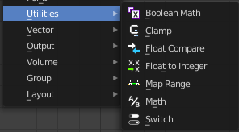
Utility nodes are mainly for mathematical operations.

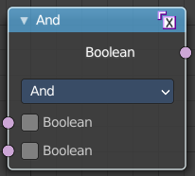
Boolean Math
The Boolean Math node performs a basic logical operation between its inputs.

Inputs

Boolean
Two standard Boolean inputs.

Properties

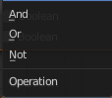
Operation

And
True if both inputs are true.

Or
True if either or both inputs are true.

Not
True if both inputs are false.

Output
Boolean
Standard Boolean output.

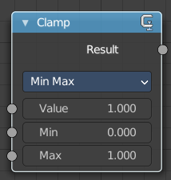
Clamp
Clamps a value between a minimum and a maximum.

Inputs

Value
The input value to be clamped.

Min
The minimum value.

Max
The maximum value.

Properties

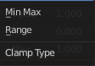
Clamp Type

Min Max
Clamp values using Min and Max values.

Range
Clamp values between Min and Max range.

Outputs

Result
The input value after clamping.

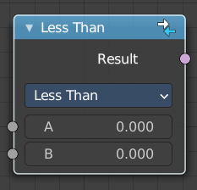
Float Compare
The Float Compare node takes two inputs and does a math comparison between them.

Inputs

A, B
Standard float value input.

Properties

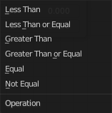
Operation

A is less than B
True if A is smaller than B.

A is lesser than or equal B
True if A is smaller or equal than B.

A is greater than B
True if A is bigger than B.

A is greater than or equal B
True if A is bigger or equal than B.

A is equal B
True if A and B are the same.

A is not equal B
True if A and B are different.

Output

Result
Standard Boolean output.

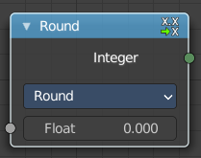
Float to Integer
Converts a floating point value into an integer value.

Inputs

Float
The input float value.

Properties

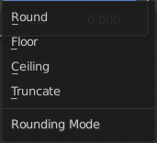
Rounding Mode
How the float value should be converted.

Outputs

Integer
The output integer value

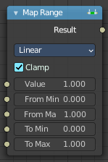
Map Range
This node converts (maps) an input value range into a destination range. By default, values outside the specified input range will be proportionally mapped as well. This node is similar to Map Value node but provides a more intuitive way to specify the desired output range.

Inputs

Value
Standard value input.

From Min
Start of the input value range.

From Max
End of the input value range.

To Min
Startof the destination range.

To Max
End of the destination range.

Properties

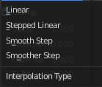
Interpolation Type
how to interpolate the values between min and max.

Clamp
Clamps values to Min/Max of the destination range.

Outputs

Value
Standard value output.

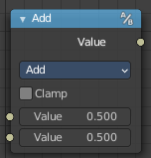
Math
The Math Node performs math operations.

Inputs
The inputs of the node are dynamic. Some inputs are only available with certain operations. For example, the Addend input is only available in the Multiply Add operator.

Value
Input Value. Trigonometric functions read this value as radians.

Addend
Input Addend.

Base
Input Base.

Exponent
Input Exponent.

Epsilon
Input Epsilon.

Distance
Input Distance.

Min
Input Minimum.

Max
Input Maximum.

Increment
Input Increment.

Scale
Input Scale.

Degrees
Input Degrees.

Radians
Input Radians.

Properties

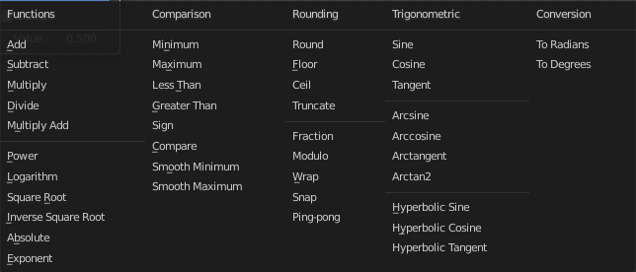
Operation
The mathematical operator to be applied to the input values:

Functions

Add
The sum of the two values.

Subtract
The difference between the two values.

Multiply
The product of the two values.

Divide
The division of the first value by the second value.

Multiply Add
The sum of the product of the two values with Addend.

Power
The Base raised to the power of Exponent.

Logarithm
The log of the value with a Base as its base.

Square Root
The square root of the value.

Inverse Square Root
One divided by the square root of the value.

Absolute
The input value is read with without regard to its sign. This turns negative values into positive values.

Exponent
Raises Euler’s number to the power of the value.

Comparison

Minimum
Outputs the smallest of the input values.

Maximum
Outputs the largest of two input values.

Less Than
Outputs 1.0 if the first value is smaller than the second value. Otherwise the output is 0.0.

Greater Than
Outputs 1.0 if the first value is larger than the second value. Otherwise the output is 0.0.

Sign
Extracts the sign of the input value. All positive numbers will output 1.0. All negative numbers will output -1.0. And 0.0 will output 0.0.

Compare
Outputs 1.0 if the difference between the two input values is less than or equal to Epsilon.

Smooth Minimum
Smooth Minimum.

Smooth Maximum
Smooth Maximum.

Rounding

Round
Round the input value to the nearest integer.

Floor
Rounds the input value down to the nearest integer.

Ceil
Rounds the input value up to the nearest integer.

Truncate
Outputs the integer part of the value.

Fraction
Fraction.

Modulo
Outputs the remainder once the first value is divided by the second value.

Wrap
Outputs a value between Min and Max based on the absolute difference between the input value and the nearest integer multiple of Max less than the value.

Snap
Round the input value to down to the nearest integer multiple of Increment.

Ping-pong
The output value is moved between 0.0 and the Scale based on the input value.

Trigonometric

Sine
The Sine of the input value.

Cosine
The Cosine of the input value.

Tangent
The Tangent of the input value.

Arcsine
The Arcsine of the input value.

Arccosine
The Arccosine of the input value.

Arctangent
The Arctangent of the input value.

Arctan2
Outputs the Inverse Tangent of the first value divided by the second value measured in radians.

Hyperbolic Sine
The Hyperbolic Sine of the input value.

Hyperbolic Cosine
The Hyperbolic Cosine of the input value.

Hyperbolic Tangent
The Hyperbolic Tangent of the input value.

Conversion

To Radians
Converts the input from degrees to radians.

To Degrees
Converts the input from radians to degrees.

Clamp
Limits the output to the range (0.0 to 1.0). See Clamp.

Outputs

Value
Numerical value output.

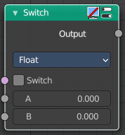
Switch
Switch between two inputs values based on a boolean.

Inputs

Switch
The boolean switch.

A
The input value A. Used when the switch is off.

B
The input value B. Used when the switch is on.

Properties

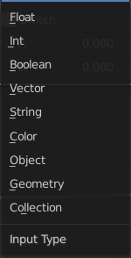
Input Type
What input type the values are, which defines what type to output then.

Outputs

Output
Numerical value output.

